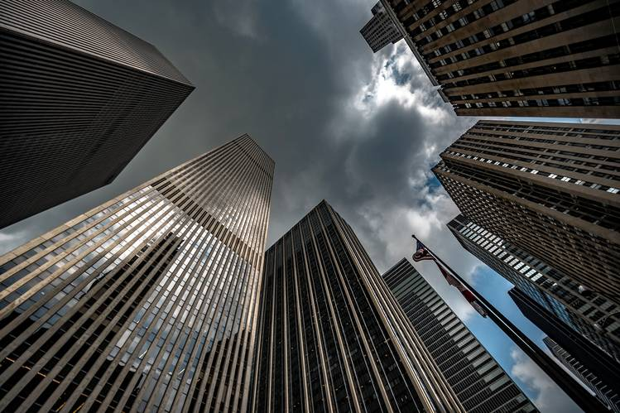
BUILDING INFORMATION REPORT

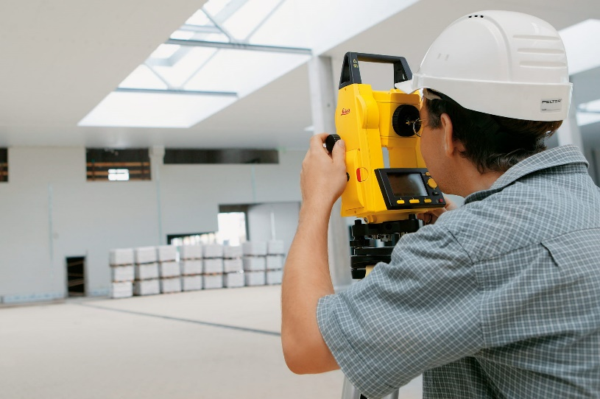
Project: ACI2 Site ID #####
Address: Address
City, ST Zip Code

TABLE OF CONTENTS

1.0 PROJECT INFORMATION 3
1.1 DIRECTORY 3
1.2 PROJECT BRIEF 4
2.0 PROJECT SITE 5
2.1 PARKING LOT 5
2.2 PARKING FACILITY ASSESSEMENT 6
3.0 ARCHITECTURAL 8
3.1 EXTERIOR WALLS 9
3.2 DOORS 10
3.3 RECEPTION AREA FACILITY ASSESSMENT 13
3.4 EXAM ROOMS FACILITY ASSESSMENT 20
3.5 BOH AREA FACILITY ASSESSMENT 27
3.6 RESTROOM FACILITY ASSESSMENT 34
4.0 MECHANICAL, ELECTRICAL, & PLUMBING 41
4.1 ELECTRICAL ELEMENTS 42
4.1A ELECTRICAL PANELS 42
4.2 PLUMBING ELEMENTS 44
4.2A WATER HEATER 44
4.3 MECHANICAL ELEMENTS 45
4.3A HVAC UNITS 45
5.0 ROOFING 48
5.1 ROOF 49
5.2 ROOFING FACILITY ASSESSMENT 50
6.0 ADA COMPLIANCE 55
6.1 EXTERIOR 56
6.2 IN-SPACE RESTROOMS 57

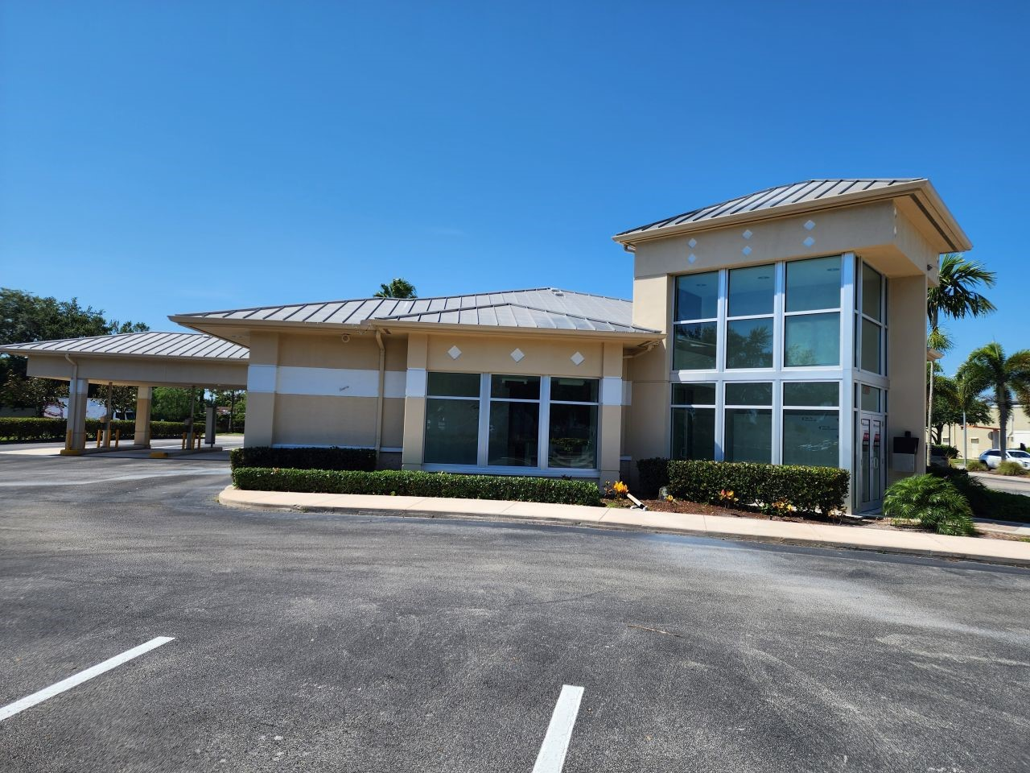
1.0 PROJECT INFORMATION

1.1 Directory
1.2 Project Brief

1.1 DIRECTORY
 | Company, Contact Name, Title |  | Address | Phone, Email, Website
Client |  | Client  Contact Name  Contact Title | (Site Address)  Address Line 1  City, ST ZIP | (###) ###-####  Client Email  Client Website
Building Contact |  | Contact Company  Contact Name  Title | (Site Address)  Address Line 1  City, ST ZIP | (###) ###-####  Contact Email  Contact Website
Surveyor |  | Field Services Unlimited  Project Manager Name  Project Manager | 6300 E Hampden Ave.  Unit C #378  Denver, CO 80222 | O: (303) 355-7274  Project Manager’s Email  www.fsusurveyor.com
Electrical Supplier |  | Company  Contact Name  Title | Address Line 1  City, ST ZIP | (###) ###-####  Contact Email  Contact Website
Gas Supplier |  | Company  Contact Name  Title | Address Line 1  City, ST ZIP | (###) ###-####  Contact Email  Contact Website
Water Supplier |  | Company  Contact Name  Title | Address Line 1  City, ST ZIP | (###) ###-####  Contact Email  Contact Website
Telephone/Data Service Provider |  | Company  Contact Name  Title | Address Line 1  City, ST ZIP | (###) ###-####  Contact Email  Contact Website
Trash Collection |  | Company  Contact Name  Title | Address Line 1  City, ST ZIP | (###) ###-####  Contact Email  Contact Website

1.2 PROJECT BRIEF
Address | (Site Address)  Address Line 1  City, ST ZIP
Proposed Square Footage | #### SF – from Quickbase
Surveyed Square Footage | #### SF – from CAD
Type of survey | Remodel? New Store? Acquisition?

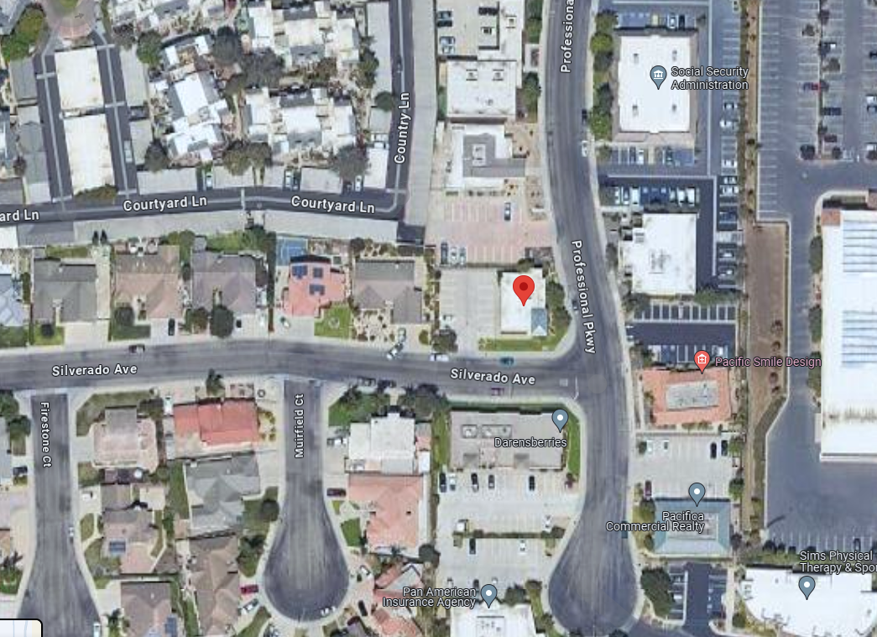
2.0 PROJECT SITE

2.1 Parking Lot
2.2 Parking Facility Assessment

2.1 PARKING LOT

PARKING | ☐ Check if table does not apply  Choose an item.
Parking Lot Type | Asphalt? Concrete? Combination?
Does the Parking Lot Need to be Resealed? | Describe.

**Add a photo of the parking lot below.

2.2 PARKING FACILITY ASSESSEMENT

**Add photos of the parking lot below.
PARKING SURFACE | Yes | No | 0-20% | 21-40% | 41% & up | Notes:
Cracking | ☐ | ☐ | ☐ | ☐ | ☐
Potholes | ☐ | ☐ | ☐ | ☐ | ☐
Patching | ☐ | ☐ | ☐ | ☐ | ☐
Other | ☐ | ☐ | ☐ | ☐ | ☐
SURFACE STRUCTURE | Yes | No | 0-20% | 21-40% | 41% & up | Notes:
Depression | ☐ | ☐ | ☐ | ☐ | ☐
Washout | ☐ | ☐ | ☐ | ☐ | ☐
Ponding | ☐ | ☐ | ☐ | ☐ | ☐
Buckling | ☐ | ☐ | ☐ | ☐ | ☐
Other | ☐ | ☐ | ☐ | ☐ | ☐
PARKING LOT STRIPING CONDITION | Yes | No | 0-20% | 21-40% | 41% & up | Notes:
Cracking | ☐ | ☐ | ☐ | ☐ | ☐
Fading | ☐ | ☐ | ☐ | ☐ | ☐
Peeling | ☐ | ☐ | ☐ | ☐ | ☐
Missing | ☐ | ☐ | ☐ | ☐ | ☐
Other | ☐ | ☐ | ☐ | ☐ | ☐

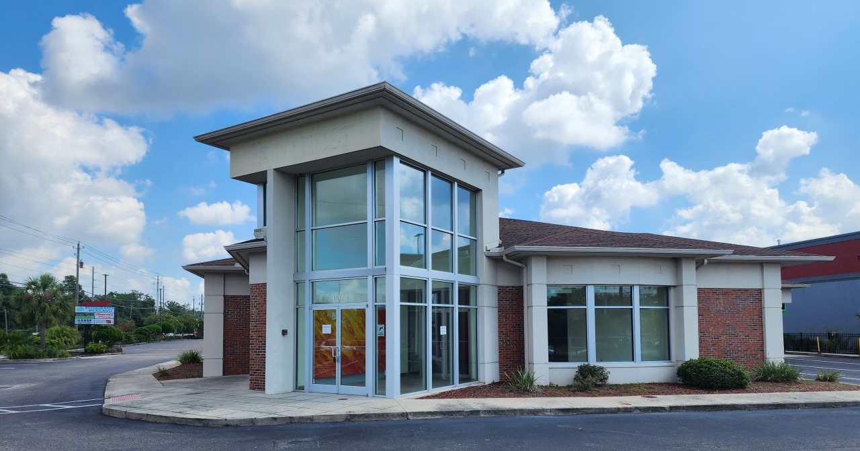
3.0 ARCHITECTURAL

3.1 Exterior Walls
3.2 Doors
3.3 Reception Area Facility Assessment
3.4 Exam Rooms Facility Assessment
3.5 BOH Area Faciltiy Assessment
3.6 Restroom Facility Assessment

3.1 EXTERIOR WALLS
Building Exterior ☐ Check if table does not apply
Choose an item.
Does the Site Have a Building Exterior? | Yes/No?
Type of Building Exterior | Describe. Brick? Block? Wood? Stucco? Metal?

Exterior Walls Facility Assessment ☐ Check if table does not apply
Choose an item.
Assessment | Yes | No | 0-20% | 21-40% | 41% & up | Notes:
Cracking | ☐ | ☐ | ☐ | ☐ | ☐
Peeling | ☐ | ☐ | ☐ | ☐ | ☐
Stained | ☐ | ☐ | ☐ | ☐ | ☐
Visible Structural Damage | ☐ | ☐ | ☐ | ☐ | ☐
Window Damage | ☐ | ☐ | ☐ | ☐ | ☐
Window Seal Damage | ☐ | ☐ | ☐ | ☐ | ☐
Caulking Damage | ☐ | ☐ | ☐ | ☐ | ☐
Holes | ☐ | ☐ | ☐ | ☐ | ☐
Other | ☐ | ☐ | ☐ | ☐ | ☐

3.2 DOORS

Entry Doors ☐ Check if table does not apply
Choose an item.
Exterior Entry Doors | Yes/No?
Type of Entrance Door | Describe. Single door? Double door? Manual sliding door? Automatic sliding door?
Exterior Exit Doors | Yes/No?
Type of Exit Door | Describe. Single door? Double door? Manual sliding door? Automatic sliding door?
Door Material | Describe. Metal? Wood? Solid Core? Hollow Core?

Exterior Entry Door Facility Assessment ☐ Check if table does not apply
Choose an item.
Assessment | Yes | No | 0-20% | 21-40% | 41% & up | Notes:
Finish Faded | ☐ | ☐ | ☐ | ☐ | ☐
Finish Rusting/Peeling | ☐ | ☐ | ☐ | ☐ | ☐
Graffiti | ☐ | ☐ | ☐ | ☐ | ☐
Hardware Damaged/Missing | ☐ | ☐ | ☐ | ☐ | ☐
Door Does Not Operate | ☐ | ☐ | ☐ | ☐ | ☐
Door Seal Damaged/Missing | ☐ | ☐ | ☐ | ☐ | ☐
Visible Air Gap | ☐ | ☐ | ☐ | ☐ | ☐
Door Damaged | ☐ | ☐ | ☐ | ☐ | ☐
Other | ☐ | ☐ | ☐ | ☐ | ☐

Exterior Exit Door Facility Assessment ☐ Check if table does not apply
Choose an item.
Assessment | Yes | No | 0-20% | 21-40% | 41% & up | Notes:
Finish Faded | ☐ | ☐ | ☐ | ☐ | ☐
Finish Rusting/Peeling | ☐ | ☐ | ☐ | ☐ | ☐
Graffiti | ☐ | ☐ | ☐ | ☐ | ☐
Hardware Damaged/Missing | ☐ | ☐ | ☐ | ☐ | ☐
Door Does Not Operate | ☐ | ☐ | ☐ | ☐ | ☐
Door Seal Damaged/Missing | ☐ | ☐ | ☐ | ☐ | ☐
Visible Air Gap | ☐ | ☐ | ☐ | ☐ | ☐
Door Damaged | ☐ | ☐ | ☐ | ☐ | ☐
Other | ☐ | ☐ | ☐ | ☐ | ☐

3.3 RECEPTION AREA FACILITY ASSESSMENT

Reception Area ☐ Check if table does not apply
Choose an item.
Is there a reception area? | Yes/No?
How many vestibules exist? | Describe. (I.e. There is one vestibule that is 6’-0” x 7’-6”.)

Reception Area Floor Facility Assessment ☐ Check if table does not apply
Choose an item.
Reception Area Flooring Type | Describe. Concrete? VCT? LVT? Ceramic Tile? Carpet? Rolled Vinyl?
Assessment | Yes | No | 0-20% | 21-40% | 41% & up | Notes:
Faded | ☐ | ☐ | ☐ | ☐ | ☐
Worn | ☐ | ☐ | ☐ | ☐ | ☐
Stained | ☐ | ☐ | ☐ | ☐ | ☐
Frayed | ☐ | ☐ | ☐ | ☐ | ☐
Cracking | ☐ | ☐ | ☐ | ☐ | ☐
Discolored | ☐ | ☐ | ☐ | ☐ | ☐
Other | ☐ | ☐ | ☐ | ☐ | ☐

Reception Area Walls Facility Assessment ☐ Check if table does not apply
Choose an item.
Reception Area Wall Finish | Describe. Gypsum board? Concrete? CMU? Brick? Exposed steel? Wood? Stucco? Paneling? Wallpaper?
Assessment | Yes | No | 0-20% | 21-40% | 41% & up | Notes:
Stained | ☐ | ☐ | ☐ | ☐ | ☐
Visible Water Damage | ☐ | ☐ | ☐ | ☐ | ☐
Cracks | ☐ | ☐ | ☐ | ☐ | ☐
Holes | ☐ | ☐ | ☐ | ☐ | ☐
Visible Structure Damage | ☐ | ☐ | ☐ | ☐ | ☐
Needs Patch/Repair | ☐ | ☐ | ☐ | ☐ | ☐
Other | ☐ | ☐ | ☐ | ☐ | ☐

Reception Area Ceiling Facility Assessment ☐ Check if table does not apply
Choose an item.
Reception Area Ceiling Type | Describe. Gypsum board? ACT? Open to deck? Wood? Paneling?
Assessment | Yes | No | 0-20% | 21-40% | 41% & up | Notes:
Stained | ☐ | ☐ | ☐ | ☐ | ☐
Visible Water Damage | ☐ | ☐ | ☐ | ☐ | ☐
Cracks | ☐ | ☐ | ☐ | ☐ | ☐
Missing Tiles | ☐ | ☐ | ☐ | ☐ | ☐
Active Leak | ☐ | ☐ | ☐ | ☐ | ☐
Visible Structure Damage | ☐ | ☐ | ☐ | ☐ | ☐
Holes | ☐ | ☐ | ☐ | ☐ | ☐
Other | ☐ | ☐ | ☐ | ☐ | ☐

Reception Area Lighting Facility Assessment ☐ Check if table does not apply
Choose an item.
Reception Area Lighting Type | Describe. Florescent? LED? Halogen? HID?
Assessment | Yes | No | 0-20% | 21-40% | 41% & up | Notes:
Bulbs Burnt Out | ☐ | ☐ | ☐ | ☐ | ☐
Lenses Cracked/Missing | ☐ | ☐ | ☐ | ☐ | ☐
Lenses Stained | ☐ | ☐ | ☐ | ☐ | ☐
Bulbs Missing | ☐ | ☐ | ☐ | ☐ | ☐
Fixtures Damaged | ☐ | ☐ | ☐ | ☐ | ☐
Other | ☐ | ☐ | ☐ | ☐ | ☐

Reception Area Doors Facility Assessment ☐ Check if table does not apply
Choose an item.
Does the reception area have doors? | Yes/No?
Type of Doors | Describe. Single door? Double door? Manual sliding door? Automatic sliding door?
Door Material | Describe. Metal? Wood? Solid Core? Hollow Core?
Assessment | Yes | No | 0-20% | 21-40% | 41% & up | Notes:
Finish Faded | ☐ | ☐ | ☐ | ☐ | ☐
Finish Rusting/Peeling | ☐ | ☐ | ☐ | ☐ | ☐
Graffiti | ☐ | ☐ | ☐ | ☐ | ☐
Hardware Damaged/Missing | ☐ | ☐ | ☐ | ☐ | ☐
Door Does Not Operate | ☐ | ☐ | ☐ | ☐ | ☐
Door Seal Damaged/Missing | ☐ | ☐ | ☐ | ☐ | ☐
Visible Air Gap | ☐ | ☐ | ☐ | ☐ | ☐
Door Damaged | ☐ | ☐ | ☐ | ☐ | ☐
Other | ☐ | ☐ | ☐ | ☐ | ☐

Reception Area Columns Facility Assessment ☐ Check if table does not apply
Choose an item.
Type of Columns | Describe. Exposed? Wrapped? Steel? Concrete? Wood? Boxed steel? H-beam steel? Round steel? Fire protected?
Assessment | Yes | No | 0-20% | 21-40% | 41% & up | Notes:
Faded/Rusted/Peeling | ☐ | ☐ | ☐ | ☐ | ☐
Wrap Damaged | ☐ | ☐ | ☐ | ☐ | ☐
Visible Structural Damage | ☐ | ☐ | ☐ | ☐ | ☐
Other | ☐ | ☐ | ☐ | ☐ | ☐

Reception Area Window Facility Assessment ☐ Check if table does not apply
Choose an item.
Are there reception area windows? | Yes/No?
Assessment | Yes | No | 0-20% | 21-40% | 41% & up | Notes:
Damaged/Missing Caulking | ☐ | ☐ | ☐ | ☐ | ☐
Graffiti | ☐ | ☐ | ☐ | ☐ | ☐
Glass Damaged/Scratched | ☐ | ☐ | ☐ | ☐ | ☐
Mullions Damaged | ☐ | ☐ | ☐ | ☐ | ☐
Seal Damage | ☐ | ☐ | ☐ | ☐ | ☐
Other | ☐ | ☐ | ☐ | ☐ | ☐

3.4 EXAM ROOMS FACILITY ASSESSMENT

Exam Rooms ☐ Check if table does not apply
Choose an item.
Are there exam rooms? | Yes/No?
How many exam rooms exist? | Describe.

Exam Rooms Floor Facility Assessment ☐ Check if table does not apply
Choose an item.
Exam Room Flooring Type | Describe. Concrete? VCT? LVT? Ceramic Tile? Carpet? Rolled Vinyl?
Assessment | Yes | No | 0-20% | 21-40% | 41% & up | Notes:
Faded | ☐ | ☐ | ☐ | ☐ | ☐
Worn | ☐ | ☐ | ☐ | ☐ | ☐
Stained | ☐ | ☐ | ☐ | ☐ | ☐
Frayed | ☐ | ☐ | ☐ | ☐ | ☐
Cracking | ☐ | ☐ | ☐ | ☐ | ☐
Discolored | ☐ | ☐ | ☐ | ☐ | ☐
Other | ☐ | ☐ | ☐ | ☐ | ☐

Exam Rooms Walls Facility Assessment ☐ Check if table does not apply
Choose an item.
Exam Room Wall Type | Describe. Gypsum board? Concrete? CMU? Brick? Exploded steel? Wood? Stucco? Paneling? Wallpaper?
Assessment | Yes | No | 0-20% | 21-40% | 41% & up | Notes:
Stained | ☐ | ☐ | ☐ | ☐ | ☐
Visible Water Damage | ☐ | ☐ | ☐ | ☐ | ☐
Cracks | ☐ | ☐ | ☐ | ☐ | ☐
Holes | ☐ | ☐ | ☐ | ☐ | ☐
Visible Structure Damage | ☐ | ☐ | ☐ | ☐ | ☐
Needs Patch/Repair | ☐ | ☐ | ☐ | ☐ | ☐
Other | ☐ | ☐ | ☐ | ☐ | ☐

Exam Rooms Ceiling Facility Assessment ☐ Check if table does not apply
Choose an item.
Exam Rooms Ceiling Type | Describe. Gypsum board? ACT? Open to deck? Wood? Paneling?
Assessment | Yes | No | 0-20% | 21-40% | 41% & up | Notes:
Stained | ☐ | ☐ | ☐ | ☐ | ☐
Visible Water Damage | ☐ | ☐ | ☐ | ☐ | ☐
Cracks | ☐ | ☐ | ☐ | ☐ | ☐
Missing Tiles | ☐ | ☐ | ☐ | ☐ | ☐
Active Leak | ☐ | ☐ | ☐ | ☐ | ☐
Visible Structure Damage | ☐ | ☐ | ☐ | ☐ | ☐
Holes | ☐ | ☐ | ☐ | ☐ | ☐
Other | ☐ | ☐ | ☐ | ☐ | ☐

Exam Rooms Lighting Facility Assessment ☐ Check if table does not apply
Choose an item.
Exam Rooms Lighting Type | Describe. Fluorescent? LED? Halogen? HID?
Assessment | Yes | No | 0-20% | 21-40% | 41% & up | Notes:
Bulbs Burnt Out | ☐ | ☐ | ☐ | ☐ | ☐
Lenses Cracked/Missing | ☐ | ☐ | ☐ | ☐ | ☐
Lenses Stained | ☐ | ☐ | ☐ | ☐ | ☐
Bulbs Missing | ☐ | ☐ | ☐ | ☐ | ☐
Fixtures Damaged | ☐ | ☐ | ☐ | ☐ | ☐
Other | ☐ | ☐ | ☐ | ☐ | ☐

Exam Rooms Doors Facility Assessment ☐ Check if table does not apply
Choose an item.
Does the space have doors? | Yes/No?
Type of Doors | Describe. Single door? Double door? Manual sliding door? Automatic sliding door?
Door Material | Describe. Metal? Wood? Solid core? Hollow core?
Assessment | Yes | No | 0-20% | 21-40% | 41% & up | Notes:
Finish Faded | ☐ | ☐ | ☐ | ☐ | ☐
Finish Rusting/Peeling | ☐ | ☐ | ☐ | ☐ | ☐
Graffiti | ☐ | ☐ | ☐ | ☐ | ☐
Hardware Damaged/Missing | ☐ | ☐ | ☐ | ☐ | ☐
Door Does Not Operate | ☐ | ☐ | ☐ | ☐ | ☐
Door Seal Damaged/Missing | ☐ | ☐ | ☐ | ☐ | ☐
Visible Air Gap | ☐ | ☐ | ☐ | ☐ | ☐
Door Damaged | ☐ | ☐ | ☐ | ☐ | ☐
Other | ☐ | ☐ | ☐ | ☐ | ☐

Exam Rooms Columns Facility Assessment ☐ Check if table does not apply
Choose an item.
Are there exam room columns? | Yes/No?
Exam Room Column Types | Describe. Exposed? Wrapped? Steel? Concrete? Wood? Boxed steel? H-Beam steel? Round steel? Fire protected?
Assessment | Yes | No | 0-20% | 21-40% | 41% & up | Notes:
Faded/Rusted/Peeling | ☐ | ☐ | ☐ | ☐ | ☐
Wrap Damaged | ☐ | ☐ | ☐ | ☐ | ☐
Visible Structural Damage | ☐ | ☐ | ☐ | ☐ | ☐
Other | ☐ | ☐ | ☐ | ☐ | ☐

Exam Rooms Window Facility Assessment ☐ Check if table does not apply
Choose an item.
Are there exam room windows? | Yes/No?
Assessment | Yes | No | 0-20% | 21-40% | 41% & up | Notes:
Damaged/Missing Caulking | ☐ | ☐ | ☐ | ☐ | ☐
Graffiti | ☐ | ☐ | ☐ | ☐ | ☐
Glass Damaged/Scratched | ☐ | ☐ | ☐ | ☐ | ☐
Mullions Damaged | ☐ | ☐ | ☐ | ☐ | ☐
Seal Damage | ☐ | ☐ | ☐ | ☐ | ☐
Other | ☐ | ☐ | ☐ | ☐ | ☐

3.5 BOH AREA FACILITY ASSESSMENT
BOH Area Floor Facility Assessment ☐ Check if table does not apply
Choose an item.
BOH Area Flooring Type | Describe. Concrete? VCT? LVT? Ceramic Tile? Carpet? Rolled Vinyl?
Assessment | Yes | No | 0-20% | 21-40% | 41% & up | Notes:
Faded | ☐ | ☐ | ☐ | ☐ | ☐
Worn | ☐ | ☐ | ☐ | ☐ | ☐
Stained | ☐ | ☐ | ☐ | ☐ | ☐
Frayed | ☐ | ☐ | ☐ | ☐ | ☐
Cracking | ☐ | ☐ | ☐ | ☐ | ☐
Discolored | ☐ | ☐ | ☐ | ☐ | ☐
Other | ☐ | ☐ | ☐ | ☐ | ☐

BOH Area ☐ Check if table does not apply
Choose an item.
Is there a break room? | Yes/No?
Is there a kitchen area? | Yes/No?
Are there storage areas? | Yes/No?

BOH Area Walls Facility Assessment ☐ Check if table does not apply
Choose an item.
BOH Area Wall Finish | Describe. Gypsum board? Concrete? CMU? Brick? Exposed steel? Wood? Stucco? Paneling? Wallpaper?
Assessment | Yes | No | 0-20% | 21-40% | 41% & up | Notes:
Stained | ☐ | ☐ | ☐ | ☐ | ☐
Visible Water Damage | ☐ | ☐ | ☐ | ☐ | ☐
Cracks | ☐ | ☐ | ☐ | ☐ | ☐
Holes | ☐ | ☐ | ☐ | ☐ | ☐
Visible Structure Damage | ☐ | ☐ | ☐ | ☐ | ☐
Needs Patch/Repair | ☐ | ☐ | ☐ | ☐ | ☐
Other | ☐ | ☐ | ☐ | ☐ | ☐

BOH Area Ceiling Facility Assessment ☐ Check if table does not apply
Choose an item.
BOH Area Ceiling Type | Describe. Gypsum board? ACT? Open to deck? Wood? Paneling?
Assessment | Yes | No | 0-20% | 21-40% | 41% & up | Notes:
Stained | ☐ | ☐ | ☐ | ☐ | ☐
Visible Water Damage | ☐ | ☐ | ☐ | ☐ | ☐
Cracks | ☐ | ☐ | ☐ | ☐ | ☐
Missing Tiles | ☐ | ☐ | ☐ | ☐ | ☐
Active Leak | ☐ | ☐ | ☐ | ☐ | ☐
Visible Structure Damage | ☐ | ☐ | ☐ | ☐ | ☐
Holes | ☐ | ☐ | ☐ | ☐ | ☐
Other | ☐ | ☐ | ☐ | ☐ | ☐

BOH Area Lighting Facility Assessment ☐ Check if table does not apply
Choose an item.
BOH Area Lighting Type | Describe. Fluorescent? LED? Halogen? HID?
Assessment | Yes | No | 0-20% | 21-40% | 41% & up | Notes:
Bulbs Burnt Out | ☐ | ☐ | ☐ | ☐ | ☐
Lenses Cracked/Missing | ☐ | ☐ | ☐ | ☐ | ☐
Lenses Stained | ☐ | ☐ | ☐ | ☐ | ☐
Bulbs Missing | ☐ | ☐ | ☐ | ☐ | ☐
Fixtures Damaged | ☐ | ☐ | ☐ | ☐ | ☐
Other | ☐ | ☐ | ☐ | ☐ | ☐

BOH Area Doors Facility Assessment ☐ Check if table does not apply
Choose an item.
Does the space have doors? | Yes/No?
Type of Doors | Describe. Single door? Double door? Manual sliding door? Automatic sliding door?
Door Material | Describe. Metal? Wood? Solid core? Hollow core?
Assessment | Yes | No | 0-20% | 21-40% | 41% & up | Notes:
Finish Faded | ☐ | ☐ | ☐ | ☐ | ☐
Finish Rusting/Peeling | ☐ | ☐ | ☐ | ☐ | ☐
Graffiti | ☐ | ☐ | ☐ | ☐ | ☐
Hardware Damaged/Missing | ☐ | ☐ | ☐ | ☐ | ☐
Door Does Not Operate | ☐ | ☐ | ☐ | ☐ | ☐
Door Seal Damaged/Missing | ☐ | ☐ | ☐ | ☐ | ☐
Visible Air Gap | ☐ | ☐ | ☐ | ☐ | ☐
Door Damaged | ☐ | ☐ | ☐ | ☐ | ☐
Other | ☐ | ☐ | ☐ | ☐ | ☐

BOH Area Columns Facility Assessment ☐ Check if table does not apply
Choose an item.
Are there BOH area columns? | Yes/No?
BOH Area Column Types | Describe. Exposed? Wrapped? Steel? Concrete? Wood? Boxed steel? H-Beam steel? Round steel? Fire protected?
Assessment | Yes | No | 0-20% | 21-40% | 41% & up | Notes:
Faded/Rusted/Peeling | ☐ | ☐ | ☐ | ☐ | ☐
Wrap Damaged | ☐ | ☐ | ☐ | ☐ | ☐
Visible Structural Damage | ☐ | ☐ | ☐ | ☐ | ☐
Other | ☐ | ☐ | ☐ | ☐ | ☐

BOH Area Window Facility Assessment ☐ Check if table does not apply
Choose an item.
Are there BOH area windows? | Yes/No?
Assessment | Yes | No | 0-20% | 21-40% | 41% & up | Notes:
Damaged/Missing Caulking | ☐ | ☐ | ☐ | ☐ | ☐
Graffiti | ☐ | ☐ | ☐ | ☐ | ☐
Glass Damaged/Scratched | ☐ | ☐ | ☐ | ☐ | ☐
Mullions Damaged | ☐ | ☐ | ☐ | ☐ | ☐
Seal Damage | ☐ | ☐ | ☐ | ☐ | ☐
Other | ☐ | ☐ | ☐ | ☐ | ☐

3.6 RESTROOM FACILITY ASSESSMENT
BOH Area ☐ Check if table does not apply
Choose an item.
Is there any existing restrooms in the space? | Yes/No?
How many restrooms exist? | Describe.
What are the restroom configurations? | Describe. Single accommodations? Multiple accommodations? Men’s? Women’s? Unisex?

Restroom Floor Facility Assessment ☐ Check if table does not apply
Choose an item.
Restroom Flooring Type | Describe. Concrete? VCT? LVT? Ceramic Tile? Carpet? Rolled Vinyl?
Assessment | Yes | No | 0-20% | 21-40% | 41% & up | Notes:
Faded | ☐ | ☐ | ☐ | ☐ | ☐
Worn | ☐ | ☐ | ☐ | ☐ | ☐
Stained | ☐ | ☐ | ☐ | ☐ | ☐
Frayed | ☐ | ☐ | ☐ | ☐ | ☐
Cracking | ☐ | ☐ | ☐ | ☐ | ☐
Discolored | ☐ | ☐ | ☐ | ☐ | ☐
Other | ☐ | ☐ | ☐ | ☐ | ☐

Restroom Walls Facility Assessment ☐ Check if table does not apply
Choose an item.
Restroom Wall Finish | Describe. Gypsum board? Concrete? CMU? Brick? Exposed steel? Wood? Stucco? Paneling? Wallpaper?
Assessment | Yes | No | 0-20% | 21-40% | 41% & up | Notes:
Stained | ☐ | ☐ | ☐ | ☐ | ☐
Visible Water Damage | ☐ | ☐ | ☐ | ☐ | ☐
Cracks | ☐ | ☐ | ☐ | ☐ | ☐
Holes | ☐ | ☐ | ☐ | ☐ | ☐
Visible Structure Damage | ☐ | ☐ | ☐ | ☐ | ☐
Needs Patch/Repair | ☐ | ☐ | ☐ | ☐ | ☐
Other | ☐ | ☐ | ☐ | ☐ | ☐

Restroom Ceiling Facility Assessment ☐ Check if table does not apply
Choose an item.
Restroom Ceiling Type | Describe. Gypsum board? ACT? Open to deck? Wood? Paneling?
Assessment | Yes | No | 0-20% | 21-40% | 41% & up | Notes:
Stained | ☐ | ☐ | ☐ | ☐ | ☐
Visible Water Damage | ☐ | ☐ | ☐ | ☐ | ☐
Cracks | ☐ | ☐ | ☐ | ☐ | ☐
Missing Tiles | ☐ | ☐ | ☐ | ☐ | ☐
Active Leak | ☐ | ☐ | ☐ | ☐ | ☐
Visible Structure Damage | ☐ | ☐ | ☐ | ☐ | ☐
Holes | ☐ | ☐ | ☐ | ☐ | ☐
Other | ☐ | ☐ | ☐ | ☐ | ☐

Restroom Lighting Facility Assessment ☐ Check if table does not apply
Choose an item.
Restroom Lighting Types | Describe. Fluorescent? LED? Halogen? HID?
Assessment | Yes | No | 0-20% | 21-40% | 41% & up | Notes:
Bulbs Burnt Out | ☐ | ☐ | ☐ | ☐ | ☐
Lenses Cracked/Missing | ☐ | ☐ | ☐ | ☐ | ☐
Lenses Stained | ☐ | ☐ | ☐ | ☐ | ☐
Bulbs Missing | ☐ | ☐ | ☐ | ☐ | ☐
Fixtures Damaged | ☐ | ☐ | ☐ | ☐ | ☐
Other | ☐ | ☐ | ☐ | ☐ | ☐

Restroom Doors Facility Assessment ☐ Check if table does not apply
Choose an item.
Do the restrooms have doors? | Yes/No?
Restroom Door Type | Describe. Single door? Double door? Manual sliding door? Automatic sliding door?
Restroom Door Material | Describe. Metal? Wood? Solid core? Hollow core?
Assessment | Yes | No | 0-20% | 21-40% | 41% & up | Notes:
Finish Faded | ☐ | ☐ | ☐ | ☐ | ☐
Finish Rusting/Peeling | ☐ | ☐ | ☐ | ☐ | ☐
Graffiti | ☐ | ☐ | ☐ | ☐ | ☐
Hardware Damaged/Missing | ☐ | ☐ | ☐ | ☐ | ☐
Door Does Not Operate | ☐ | ☐ | ☐ | ☐ | ☐
Door Seal Damaged/Missing | ☐ | ☐ | ☐ | ☐ | ☐
Visible Air Gap | ☐ | ☐ | ☐ | ☐ | ☐
Door Damaged | ☐ | ☐ | ☐ | ☐ | ☐
Other | ☐ | ☐ | ☐ | ☐ | ☐

Restroom Window Facility Assessment ☐ Check if table does not apply
Choose an item.
Are there restroom windows? | Yes/No?
Assessment | Yes | No | 0-20% | 21-40% | 41% & up | Notes:
Damaged/Missing Caulking | ☐ | ☐ | ☐ | ☐ | ☐
Graffiti | ☐ | ☐ | ☐ | ☐ | ☐
Glass Damaged/Scratched | ☐ | ☐ | ☐ | ☐ | ☐
Mullions Damaged | ☐ | ☐ | ☐ | ☐ | ☐
Seal Damage | ☐ | ☐ | ☐ | ☐ | ☐
Other | ☐ | ☐ | ☐ | ☐ | ☐

Restroom Fixtures Facility Assessment ☐ Check if table does not apply
Choose an item.
What types of fixtures exist in the restroom? | Describe. Toilet? Urinal? Lavatory? Partitions?
Assessment | Yes | No | 0-20% | 21-40% | 41% & up | Notes:
Stained/Graffiti | ☐ | ☐ | ☐ | ☐ | ☐
Chips/Cracks | ☐ | ☐ | ☐ | ☐ | ☐
Damaged | ☐ | ☐ | ☐ | ☐ | ☐
Operational? | ☐ | ☐ | ☐ | ☐ | ☐
Other | ☐ | ☐ | ☐ | ☐ | ☐

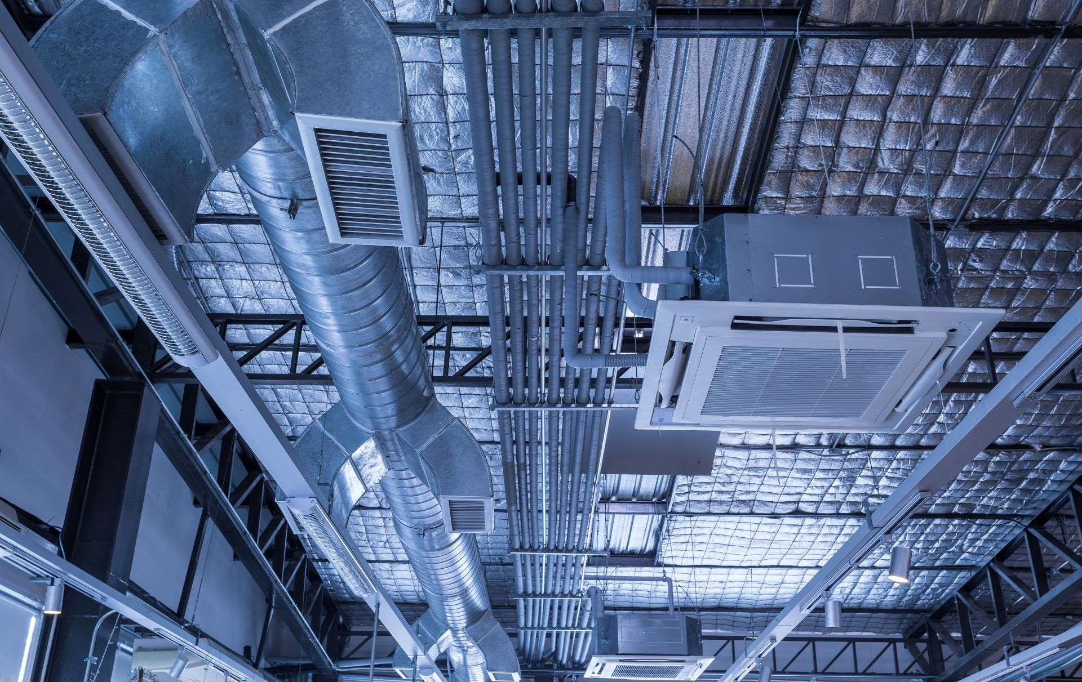
4.0 MECHANICAL, ELECTRICAL, & PLUMBING

4.1 Electrical Elements
4.1A Electrical Panels
4.2 Plumbing Elements
4.2A Water Heater
4.3 Mechanical Elements
4.3A HVAC Units

4.1 ELECTRICAL ELEMENTS

4.1A ELECTRICAL PANELS
Electrical Panel #1 ☐ Check if table does not apply
Choose an item.
Panel Name
Manufacturer
Voltage
Amps
Main Breaker |  | Yes/No?
Phase
Wire
Polls |  | # used of # total
Circuit | Amps | Use/Label | Circuit | Amps | Use/Label
1 |  |  | 2
3 |  |  | 4
5 |  |  | 6
7 |  |  | 8
9 |  |  | 10
11 |  |  | 12
13 |  |  | 14
15 |  |  | 16
17 |  |  | 18
19 |  |  | 20
21 |  |  | 22
23 |  |  | 24
25 |  |  | 26
27 |  |  | 28
29 |  |  | 30
31 |  |  | 32
33 |  |  | 34
35 |  |  | 36
37 |  |  | 38
39 |  |  | 40
41 |  |  | 42
**Add photos of the panel open and the label.

**Add photos of the panel open and the label.

Electrical Panel #2 ☐ Check if table does not apply
Choose an item.
Panel Name
Manufacturer
Voltage
Amps
Main Breaker |  | Yes/No?
Phase
Wire
Polls |  | # used of # total
Circuit | Amps | Use/Label | Circuit | Amps | Use/Label
1 |  |  | 2
3 |  |  | 4
5 |  |  | 6
7 |  |  | 8
9 |  |  | 10
11 |  |  | 12
13 |  |  | 14
15 |  |  | 16
17 |  |  | 18
19 |  |  | 20
21 |  |  | 22
23 |  |  | 24
25 |  |  | 26
27 |  |  | 28
29 |  |  | 30
31 |  |  | 32
33 |  |  | 34
35 |  |  | 36
37 |  |  | 38
39 |  |  | 40
41 |  |  | 42
**Add additional tables as needed.

4.2 PLUMBING ELEMENTS

4.2A WATER HEATER

Water Heater ☐ Check if table does not apply
Choose an item.
Is there a water heater servicing the space? | Yes/No?
Does the water heater appear to be working? | Yes/No?
Manufacturer | Describe
Model # | Describe
Serial # | Describe
Size | Describe

4.3 MECHANICAL ELEMENTS

4.3A HVAC UNITS

HVAC UNIT #1 ☐ Check if table does not apply
Choose an item.
Location | Describe the location and which suite it serves.
Type of System | Describe
Manufacturer | Describe
Model # | Describe
Serial # | Describe
Volts: | Describe
Unit Age | Describe
Tonnage | Describe
Power Source | Gas? Electric? Both?
KW/HP | Describe
Min. Circuit Amps | Describe
Visual Inspection | N.A. | Good | Fair | Poor | Notes:
Condition of Cabinet | ☐ | ☐ | ☐ | ☐
Condition of Flashing at Curb | ☐ | ☐ | ☐ | ☐
Condition of Outdoor Air Screen | ☐ | ☐ | ☐ | ☐
Condition of Piping / Drain Lines | ☐ | ☐ | ☐ | ☐
Other Visible Damage | ☐ | ☐ | ☐ | ☐
Operational? | Yes/No?
Unit Control | Eclectic? Pneumatic?
Control Type and Make | Thermostat? Remote Sensor? Make?

HVAC UNIT #2 ☐ Check if table does not apply
Choose an item.
Location | Describe the location and which suite it serves.
Type of System | Describe
Manufacturer | Describe
Model # | Describe
Serial # | Describe
Volts: | Describe
Unit Age | Describe
Tonnage | Describe
Power Source | Gas? Electric? Both?
KW/HP | Describe
Min. Circuit Amps | Describe
Visual Inspection | N.A. | Good | Fair | Poor | Notes:
Condition of Cabinet | ☐ | ☐ | ☐ | ☐
Condition of Flashing at Curb | ☐ | ☐ | ☐ | ☐
Condition of Outdoor Air Screen | ☐ | ☐ | ☐ | ☐
Condition of Piping / Drain Lines | ☐ | ☐ | ☐ | ☐
Other Visible Damage | ☐ | ☐ | ☐ | ☐
Operational? | Yes/No?
Unit Control | Eclectic? Pneumatic?
Control Type and Make | Thermostat? Remote Sensor? Make?

**Add photos of the unit and label below.

HVAC UNIT #3 ☐ Check if table does not apply
Choose an item.
Location | Describe the location and which suite it serves.
Type of System | Describe
Manufacturer | Describe
Model # | Describe
Serial # | Describe
Volts: | Describe
Unit Age | Describe
Tonnage | Describe
Power Source | Gas? Electric? Both?
KW/HP | Describe
Min. Circuit Amps | Describe
Visual Inspection | N.A. | Good | Fair | Poor | Notes:
Condition of Cabinet | ☐ | ☐ | ☐ | ☐
Condition of Flashing at Curb | ☐ | ☐ | ☐ | ☐
Condition of Outdoor Air Screen | ☐ | ☐ | ☐ | ☐
Condition of Piping / Drain Lines | ☐ | ☐ | ☐ | ☐
Other Visible Damage | ☐ | ☐ | ☐ | ☐
Operational? | Yes/No?
Unit Control | Eclectic? Pneumatic?
Control Type and Make | Thermostat? Remote Sensor? Make?

**Add photos of the unit and label below.
**Add tables as needed.

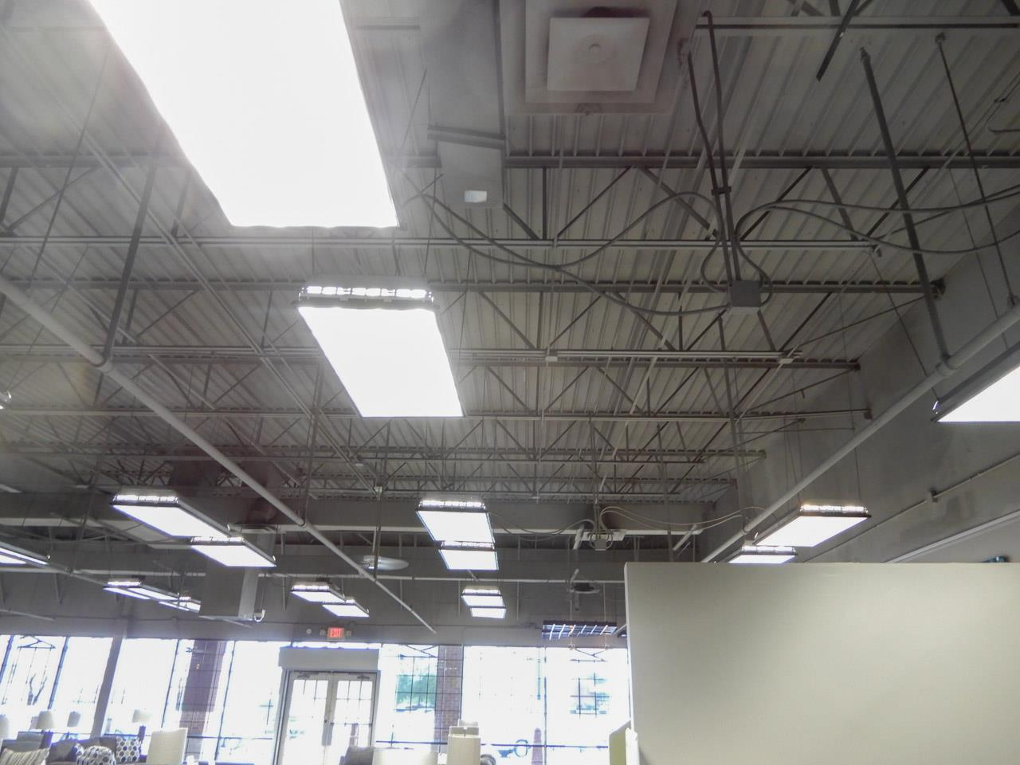
5.0 ROOFING

5.1 Roof
5.2 Roofing Facility Assessment

5.1 ROOF

Roof ☐ Check if table does not apply
Choose an item.
Roof Type | Describe. Metal? Membrane? Shingle?
Estimated Age of Roof | Describe.
Overall Condition of Roof | Describe.
Are there indications of recent roof repairs? | Describe.

**Add photos of roof.

5.2 ROOFING FACILITY ASSESSMENT

Counter Flashing | Yes | No | 0-20% | 21-40% | 41% & up | Notes: ☐ Check if table does not apply  Choose an item.
Loose/Missing Fasteners | ☐ | ☐ | ☐ | ☐ | ☐
Loose/Displaced Metal | ☐ | ☐ | ☐ | ☐ | ☐
Deformed Metal | ☐ | ☐ | ☐ | ☐ | ☐
Flashing Joints | ☐ | ☐ | ☐ | ☐ | ☐
Punctures | ☐ | ☐ | ☐ | ☐ | ☐
Other | ☐ | ☐ | ☐ | ☐ | ☐

Coping/Cap Flashing | Yes | No | 0-20% | 21-40% | 41% & up | Notes: ☐ Check if table does not apply  Choose an item.
Loose/Missing Fasteners | ☐ | ☐ | ☐ | ☐ | ☐
Loose/Displaced Metal | ☐ | ☐ | ☐ | ☐ | ☐
Deformed Metal | ☒ | ☐ | ☐ | ☐ | ☐
Flashing Joints | ☐ | ☐ | ☐ | ☐ | ☐
Punctures | ☐ | ☐ | ☐ | ☐ | ☐
Cracked/Broken Coping | ☐ | ☐ | ☐ | ☐ | ☐
Open Coping Joint | ☐ | ☐ | ☐ | ☐ | ☐
Other | ☐ | ☐ | ☐ | ☐ | ☐

Expansion Joint | Yes | No | 0-20% | 21-40% | 41% & up | Notes: ☐ Check if table does not apply  Choose an item.
Punctures | ☐ | ☐ | ☐ | ☐ | ☐
Splitting | ☐ | ☐ | ☐ | ☐ | ☐
Mechanical Damage | ☐ | ☐ | ☐ | ☐ | ☐
Hinder Damage | ☐ | ☐ | ☐ | ☐ | ☐
Other | ☐ | ☐ | ☐ | ☐ | ☐

Edge Metal | Yes | No | 0-20% | 21-40% | 41% & up | Notes: ☐ Check if table does not apply  Choose an item.
Loose/Missing Fasteners | ☐ | ☐ | ☐ | ☐ | ☐
Loose/Displaced Metal | ☐ | ☐ | ☐ | ☐ | ☐
Open Ended Joint | ☐ | ☐ | ☐ | ☐ | ☐
Sealant Joint Damage | ☐ | ☐ | ☐ | ☐ | ☐
Other | ☐ | ☐ | ☐ | ☐ | ☐

Base Flashing | Yes | No | 0-20% | 21-40% | 41% & up | Notes: ☐ Check if table does not apply  Choose an item.
Exposed Top Seal | ☐ | ☐ | ☐ | ☐ | ☐
Deterioration | ☐ | ☐ | ☐ | ☐ | ☐
Punctures | ☐ | ☐ | ☐ | ☐ | ☐
Sagging/Wrinkling | ☐ | ☐ | ☐ | ☐ | ☐
Other | ☐ | ☐ | ☐ | ☐ | ☐

Drains | Yes | No | 0-20% | 21-40% | 41% & up | Notes: ☐ Check if table does not apply  Choose an item.
Clear of Debris | ☐ | ☐ | ☐ | ☐ | ☐
Flashing Damage | ☐ | ☐ | ☐ | ☐ | ☐
Other | ☐ | ☐ | ☐ | ☐ | ☐

Roof Surface | Yes | No | 0-20% | 21-40% | 41% & up | Notes: ☐ Check if table does not apply  Choose an item.
Discoloration / Standing Water | ☐ | ☐ | ☐ | ☐ | ☐
Cracking / Wrinkling / Buckling | ☐ | ☐ | ☐ | ☐ | ☐
Punctures | ☐ | ☐ | ☐ | ☐ | ☐
Alligatoring / Blistering | ☐ | ☐ | ☐ | ☐ | ☐
Vandalism | ☐ | ☐ | ☐ | ☐ | ☐
Mechanical Damage | ☐ | ☒ | ☐ | ☐ | ☐
Exposed Felt / Deck | ☐ | ☐ | ☐ | ☐ | ☐
Soft Areas | ☐ | ☐ | ☐ | ☐ | ☐
Vegetative Growth | ☐ | ☐ | ☐ | ☐ | ☐
Bare Spots | ☐ | ☐ | ☐ | ☐ | ☐
Discoloration | ☐ | ☐ | ☐ | ☐ | ☐
Gravel Stop | ☐ | ☐ | ☐ | ☐ | ☐
Other | ☐ | ☐ | ☐ | ☐ | ☐

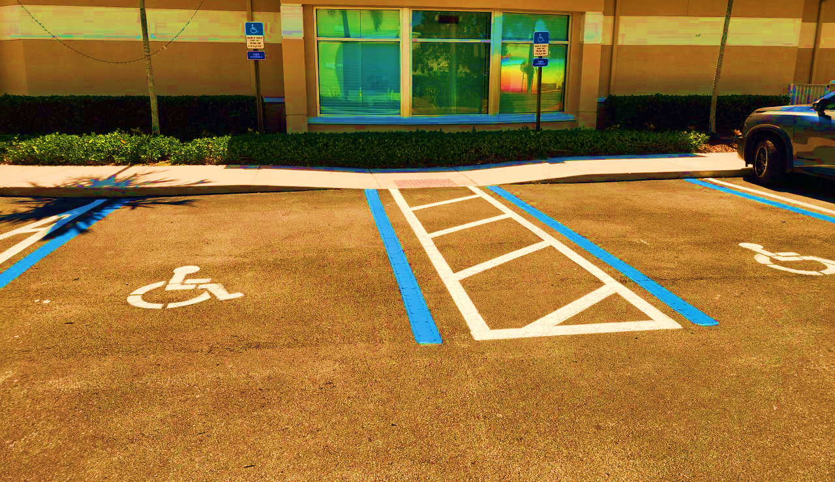
6.0 ADA COMPLIANCE

6.1 Exterior
6.2 In-Space Restrooms

6.1 EXTERIOR

Exterior ☐ Check if table does not apply
Choose an item.
ADA Parking | Is ADA parking available?
# of Levels | Describe.
Level of Site | What level is the site on?
What is the vertical means of circulation? | Describe. Stairs? Elevator? Escalator?
If vertical circulation is an elevator, how many cars are there? | Describe.
Is there a service elevator? | Yes/No?
Curb Ramp | Present? Compliant?
Front Door Condition | What is the condition of the front door to the space (not building)?
Main Entry | Accessible?
Other | Describe any other accessibility concerns.

**Add photos of parking, signage, and path of travel.

6.2 IN-SPACE RESTROOMS
Restrooms ☐ Check if table does not apply Choose an item.
Door Clearance: Is there 18” min clear on pull side and 12” min clear on push side? | Yes/No?
Does the restroom have a 56” x 60” clear floor area around the toilet with no other fixtures within the area? | Yes/No?
Is the centerline of the toilet 16”-18” from the nearest wall? | Yes/No?
CA site only: Is the center of the lavatory 15” min from wall, 18” max? | Yes/No?
CA site only: Is there 48” min clearance in front of the toilet? | Yes/No?
Is there an existing exhaust fan? | Yes/No?
Does the exhaust fan function? | Yes/No?
Is the restroom multi-person? | Yes/No?
If the restroom is multi-person, what is present? | Men’s  Toilets: #  Urinals: #  Lavatories: # | Women’s/Unisex  Toilets: #  Urinals: #  Lavatories: #
If the restroom is multi-person, are partitions present? | Yes/No?
What is the condition of partitions? | Describe. Good? Fair? Poor?
Comments | Describe anything else of note.

**Add photos of restrooms.

