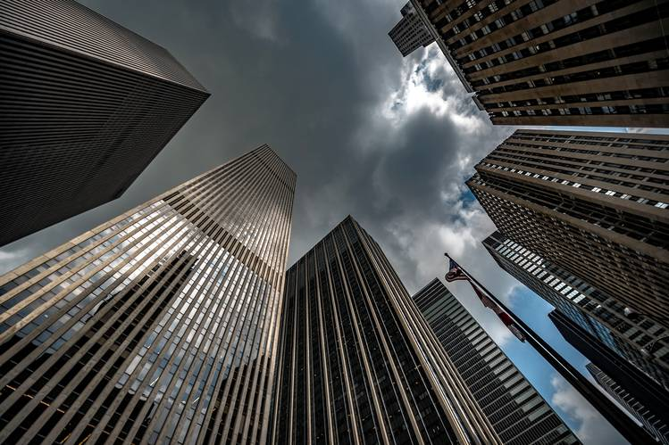
BUILDING INFORMATION REPORT

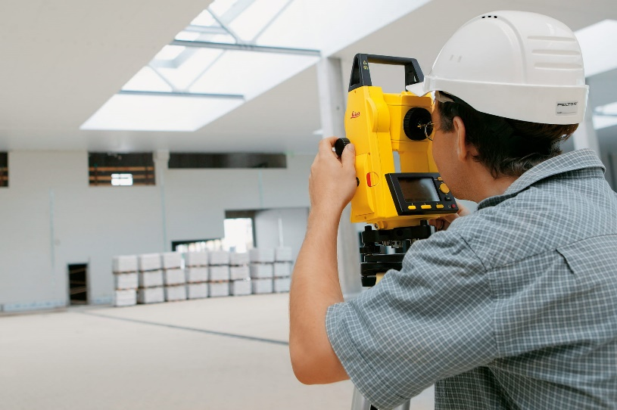
Project: HDC2 Site ID #####
Address: Address
City, ST Zip Code

TABLE OF CONTENTS

1.0 PROJECT INFORMATION 3
1.1 GENERAL SITE INFORMATION 3
1.2 SKETCHES 4
2.0 MECHANICAL, ELECTRICAL, & PLUMBING 6
2.1 ELECTRICAL ELEMENTS 7
2.1A ELECTRICAL PANELS 8
2.1B TRANSFORMER 10
2.1C GENERAL ELECTRICAL ELEMENTS 10
2.1D ELECTRICAL 1-LINE DIAGRAM 11
2.2 PLUMBING ELEMENTS 12
2.2A DOMESTIC WATER 12
2.2B WATER HEATER 12
2.2C NATURAL GAS 13
2.2D SANITARY SEWER & STORM/ROOF DRAINAGE 13
2.2E GREASE TRAP 14
2.2F SPECIAL CONDITIONS 14
2.3 MECHANICAL ELEMENTS 15
2.3A HVAC UNITS 17
2.4 SECURITY & FIRE ELEMENTS 20
2.4A FIRE SPRINKLER 20
2.4B FIRE ALARM 21

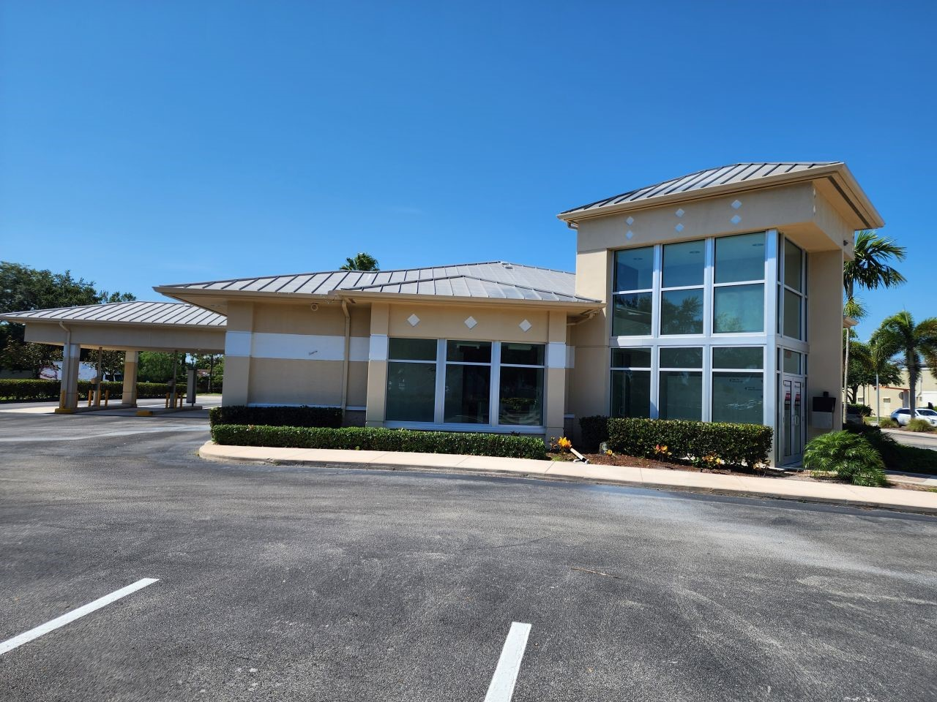
1.0 PROJECT INFORMATION

1.1 General Site Information
1.2 Sketches

1.1 GENERAL SITE INFORMATION
Address | (Site Address) Address Line 1  City, ST ZIP
Proposed Square Footage | #### SF – from Quickbase
Surveyed Square Footage | #### SF – from CAD
Property Description | Describe the area. Are there any trees or other landscapes that would affect new underground utilities or any surrounding buildings that may provide significant shade or other problems with new equipment or utilities above or below grade?
Type of Building | Strip Center? Freestanding? Multi-story (Note the # of floors)? Basement? Drive Thru?
Year Built | What year was the building constructed? Was there any major work since?
Roof Slope | Is the roof flat or pitched? If sloped, please indicate the slope.
Wall Type and Thickness | Describe. (I.e. The exterior walls are CMU with a thickness of 0’-8”. The interior walls are gypsum board finish on metal studs with a thickness of 0’-5”.)
Glass Size and Type | Describe. (I.e. The storefront is a 10% tinted single pane glazing. The glass opening is 10’-0” wide with a sill height of 1’-6” AFF and a header height of 9’-6” AFF. The mullion thickness is 0’-4 ½”.)
Above/Below Space | Describe what is above and below the space. Roof? Basement? Another tenant? Are there any factors to prevent possible chases, routes to roof, any areas below floor to avoid electrical vaults, structural slab that might limit penetrations? Any roof drains, pipes or duct hidden in column surrounds?

1.2 SKETCHES

Provide a sketch of the roof plan showing RTUs, VTRs, exhaust fans, etc. Show any designated areas reserved for HVAC equipment.

ROOF PLAN SKETCH

Document the North Direction and Surrounding Area - If no site plan, sketch the site and/or building appropriately. Provide sketch locations of: water mains, sewer, storm sewer, gas meters, electric transformers/meters, any HVAC equipment not located on the roof. (use A&A graph paper if desired).

SITE PLAN SKETCH

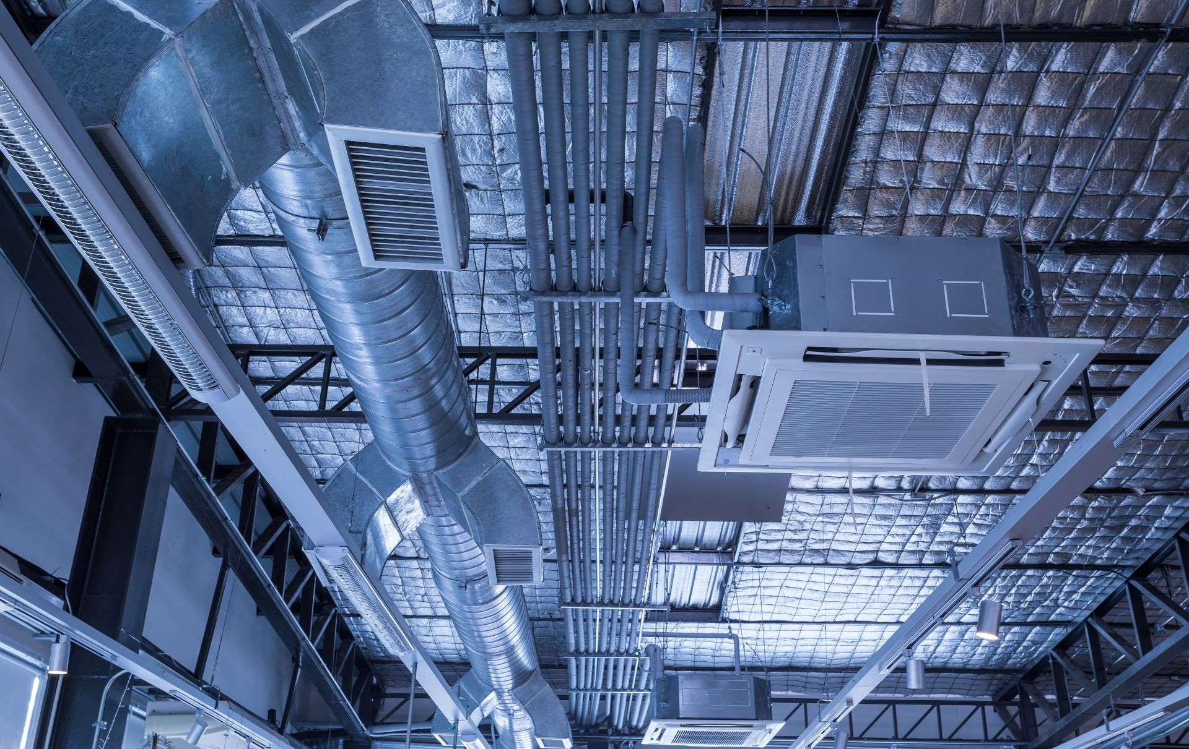
2.0 MECHANICAL, ELECTRICAL, & PLUMBING
2.1 Electrical Elements
2.1A Electrical Panels
2.1B Transformer
2.1C General Electrical Elements
2.1D Electrical 1-Line Diagram
2.2 Plumbing Elements
2.2A Domestic Water
2.2B water Heater
2.2C Natural Gas
2.2D Sanitary Sewer & Storm/Roof Drainage
2.2E Grease Trap
2.2F Special Conditions
2.3 Mechanical Elements
2.3A HVAC Units
2.4 Security & Fire Elements
2.4A Fire Sprinkler
2.4B Fire Alarm

2.1 ELECTRICAL ELEMENTS
☐ Check if table does not apply Choose an item.

2.1A ELECTRICAL PANELS
Electrical Panel #1 ☐ Check if table does not apply
Choose an item.
Panel Name
Manufacturer
Model #
Mounting |  | Surface Mounted? Recessed? Semi-Recessed?
Voltage
Amps
Main Breaker |  | If yes, what is the size?
Phase
Wire
AIC Rating |  | Amps Interrupting Capacity Rating
Condition
Circuit | Amps | Use/Label | Circuit | Amps | Use/Label
1 |  |  | 2
3 |  |  | 4
5 |  |  | 6
7 |  |  | 8
9 |  |  | 10
11 |  |  | 12
13 |  |  | 14
15 |  |  | 16
17 |  |  | 18
19 |  |  | 20
21 |  |  | 22
23 |  |  | 24
25 |  |  | 26
27 |  |  | 28
29 |  |  | 30
31 |  |  | 32
33 |  |  | 34
35 |  |  | 36
37 |  |  | 38
39 |  |  | 40
41 |  |  | 42

Electrical Panel #2 ☐ Check if table does not apply
Choose an item.
Panel Name |  | Panel Name
Manufacturer |  | Manufacturer
Model # |  | Model #
Mounting |  | Mounting
Voltage |  | Voltage
Amps |  | Amps
Main Breaker |  | Main Breaker
Phase |  | Phase
Wire |  | Wire
AIC Rating |  | AIC Rating
Condition |  | Condition
Circuit | Amps | Use/Label | Circuit | Amps | Use/Label
1 |  |  | 2
3 |  |  | 4
5 |  |  | 6
7 |  |  | 8
9 |  |  | 10
11 |  |  | 12
13 |  |  | 14
15 |  |  | 16
17 |  |  | 18
19 |  |  | 20
21 |  |  | 22
23 |  |  | 24
25 |  |  | 26
27 |  |  | 28
29 |  |  | 30
31 |  |  | 32
33 |  |  | 34
35 |  |  | 36
37 |  |  | 38
39 |  |  | 40
41 |  |  | 42

2.1B TRANSFORMER
☐ Check if table does not apply Choose an item.

2.1C GENERAL ELECTRICAL ELEMENTS
☐ Check if table does not apply Choose an item.

2.1D ELECTRICAL 1-LINE DIAGRAM
☐ Check if table does not apply Choose an item.
Document location of all space equipment on a plan and draw a complete 1-line diagram.

ELECTRICAL 1-LINE DIAGRAM

2.2 PLUMBING ELEMENTS

2.2A DOMESTIC WATER
☐ Check if table does not apply Choose an item.

2.2B WATER HEATER
☐ Check if table does not apply Choose an item.

2.2C NATURAL GAS
☐ Check if table does not apply Choose an item.

2.2D SANITARY SEWER & STORM/ROOF DRAINAGE
☐ Check if table does not apply Choose an item.

2.2E GREASE TRAP
☐ Check if table does not apply Choose an item.
2.2F SPECIAL CONDITIONS
☐ Check if table does not apply Choose an item.

2.3 MECHANICAL ELEMENTS

**Add general mechanical photos below.

HVAC System | Describe. Who Maintains? If landlord maintained, list the operating schedule. (I.e. The HVAC system is 2 RTUs dedicated to the space and maintained by the tenant.)
Clearance | Bottom of Deck: #’-#” AFF  Existing Ceiling Height: #’-#” AFF  Bottom of Structure: #’-#” AFF
Other Main Obstruction | Describe the type of obstruction and the height.
Special Conditions | e.g. - Other equipment that might remain and / or be reused, such as ventilation hoods, toilet room exhaust(s), unit or wall heaters, building ductwork, other exhaust systems, etc. Please provide nameplate information (if accessible) of any equipment & document location, duct routing, etc. on a plan.

Note or provide a sketch indicating any elements that may impact Duct Height or Routing incl. Structure, Piping, Conduit, etc. Indicate height, location and / or routing on a plan. Document on a plan the locations of each piece of equipment (incl. thermostats/sensors) & include a sketch of the diffuser layout & ductwork, if visible. Also show any available locations for exhaust, flues, outside air intakes, including proposed chase locations or areas for exterior louvers (wall or soffit).
Indicate any size (and use) of existing louvers.

MECHANICAL SKETCH

2.3A HVAC UNITS

HVAC UNIT #1 ☐ Check if table does not apply
Choose an item.
Location | Describe the location and which suite it serves.
Type of System | Describe
Manufacturer | Describe
Model # | Describe
Serial # | Describe
Unit Age | Describe
Condition | Describe
Minimum Circuit Amps (MCA) | Describe
Maximum Overcurrent Protection (MOCP) | Describe
Voltage | Describe
Phase | Describe
Gas (BTU or MBH) / Elec Heat (KW) | Describe
Main Duct Size at Unit | #’-#” W x #’-#” H or #’-#” Diameter
Return Air Ducted or Plenum | Describe. (I.e. There is a 5’-0” high plenum.)
Outside Air Intake Location | Describe
**Add photos of the unit and label below.

HVAC UNIT #2 ☐ Check if table does not apply
Choose an item.
Location | Describe the location and which suite it serves.
Type of System | Describe
Manufacturer | Describe
Model # | Describe
Serial # | Describe
Unit Age | Describe
Condition | Describe
Minimum Circuit Amps (MCA) | Describe
Maximum Overcurrent Protection (MOCP) | Describe
Voltage | Describe
Phase | Describe
Gas (BTU or MBH) / Elec Heat (KW) | Describe
Main Duct Size at Unit | #’-#” W x #’-#” H or #’-#” Diameter
Return Air Ducted or Plenum | Describe. (I.e. There is a 5’-0” high plenum.)

**Add photos of the unit and label below.

HVAC UNIT #3 ☐ Check if table does not apply
Choose an item.
Location | Describe the location and which suite it serves.
Type of System | Describe
Manufacturer | Describe
Model # | Describe
Serial # | Describe
Unit Age | Describe
Condition | Describe
Minimum Circuit Amps (MCA) | Describe
Maximum Overcurrent Protection (MOCP) | Describe
Voltage | Describe
Phase | Describe
Gas (BTU or MBH) / Elec Heat (KW) | Describe
Main Duct Size at Unit | #’-#” W x #’-#” H or #’-#” Diameter
Return Air Ducted or Plenum | Describe. (I.e. There is a 5’-0” high plenum.)
**Add photos of the unit and label below.

**Add additional tables as needed.

2.4 SECURITY & FIRE ELEMENTS

2.4A FIRE SPRINKLER

Sprinkler | ☐ Check if table does not apply  Choose an item.
Is the Space Sprinklered? | Yes/No?
Sprinkler Service Size | #’-#”
Sprinkler Service Location | Describe.
Height of Main Line Above Floor | #’-#” AFF
Landlord Sprinkler Room | Present? Location?
Is there a Flow Switch? | Yes/No?
Is there a Tamper Switch? | Yes/No? If yes, describe the location.

**Add photos of sprinkler elements.

2.4B FIRE ALARM

Fire Alarm | ☐ Check if table does not apply  Choose an item.
Does the Space Have an Alarm System? | Yes/No?
System Type? | Landlord system? Tenant system?
Fire Alarm Panel | Yes/No? If yes, describe the location.
Fire Alarm Panel Documentation | Document any information on the fire alarm panel.
Tenant System Connects to Landlord System? | Yes/No?
Tenant System Connects to Fire Dept. (Phone Line)? | Yes/No?
Types of Devices in Space | Pull Switch? Visual? A/V? Audio? Smoke Detector? Duct Smoke Detector? Ansul System? Flow Switch? Tamper Switch? Heat Detector? Remote Annunciator? Elevator Recall?
Is There a Knox Box? | Yes/No? If yes, describe the location.
Indicator Signals for HVAC? | Yes/No? If yes, describe the location.

**Add photos of fire alarm elements.

